Background info for Shuttle Van: https://www.RandolphPetitions.com/Mobility_Hub.htm
Contents
Model for Randolph: Lexpress shuttles people to 5 MBTA bus lines 1
Lexington shuttle van: 140 rides per day, since 1979 1
Lexpress shuttle van still gets grants in 2024 (and cut fares post-pandemic) 3
Lexington has 2 MBTA bus lines, plus 3 bus lines in nearby towns connected by Lexpress (none cut due to Lexpress) 4
Will MBTA cut the 240 bus due to shuttle van? (No, they have rules about what gets cut) 5
Bus network redesign principles: Prioritize needs of riders who depend on bus; more frequent service in busy neighborhoods 5
MBTA Bus Network Redesign Feb. 2023 Final Report: Rt 240 & 238 keep existing routes; we can influence the next round 9
Model for Randolph: Acton shuttles people to commuter rail 11
South Acton Commuter Rail Station: Community Transportation Technical Assistance Program: MAPC willing and able to assist Randolph 11
Town of Acton Transportation Services: MinuteVan dial-a-ride; Cross Acton Transit (CAT bus); “Acton Ride” taxi program 14
Ride the CAT: Cross Acton Transit schedule (hourly fixed route from 8 AM to 4 PM including MBTA commuter rail station) 14
Maynard–Acton Rail Shuttle: expanded to Maynard, from Acton Commuter Rail station 15

Model for Randolph: Lexpress shuttles people to 5 MBTA bus lines

Lexington shuttle van: 140 rides per day, since 1979

https://lexobserver.org/2023/12/11/lexpress-has-been-getting-people-where-they-need-to-go-since-1979/

Lexpress has been getting people where they need to go since 1979
by Tara Pai and Nikhita PrasadDecember 11, 2023
The infamous gas crisis of 1979 led to a spike in prices and lines more than 45 minutes long to fill the tank on the family car. Here in Lexington, it also led to the founding of Lexpress, Lexington’s local bus service. Today, with concerns about carbon emissions and climate change, Lexpress remains as relevant as it was then.
“I think public transit in general, whether it’s Lexpress or any other service is important because buses can serve more people per vehicle hour and vehicle mile than a car can,” Susan Barrett, the Town of Lexington Transportation Manager, said.
Initially attracting youth, the bus is now popular among senior citizens as well. Lexpress offers three routes to help Lexington residents get around the town, providing and average of 140 rides a day. Each route runs every hour from 7:30 AM to 7:30 PM, taking riders to senior homes, the Burlington Mall, Market Basket, and the Town Center, among various other locations.
To this day, Lexpress has had success in attracting customers through its affordable pricing model. Currently, an individual ride costs $2, and the Limitless Pass, which provides unlimited rides, costs only $20 year. In addition to riders’ fares, Lexpress is funded through residents’ taxes, specifically property taxes. They also occasionally get money from the MBTA and MassDOT.
“We’ve recently been awarded two grants of $200,000 to offset the cost of operations. Within the past few years between MassDOT grants and the MBTA, we’ve been able to raise over half a million dollars in external funding to support the service,” Barrett said.
In the future, Barrett hopes to expand the bus routes to make public transportation more accessible. For instance, many students do not have a way to ride to and from various destinations after school, so having a convenient option like the Lexpress would be beneficial. And it isn’t just Lexington residents that take advantage of the service; those who work in the town also use it for their daily commute.
“People have a lot of requests for service and it doesn’t appear that we’re going to be getting significant increases in MBTA service. There are some that are planned, but for the most part, to fill in these gaps, it’s going to take other services [such as the Lexpress],” Barrett said.
Barrett credits Lexpress with connecting Lexington residents and adding to the vibrancy of the town.
“One of my favorite things is how, like with any transportation service, it’s intergenerational – you have people across all generations that ride the service. What I have seen, that I think is the cutest thing ever, is when I see seniors talking with students on the bus. It’s really nice,” Barrett said.
Being a local transportation service, Lexpress drivers and riders are able to form lasting relationships with one another.
“I was riding the bus one time, and it was after school, and the driver stopped. I couldn’t figure out why he stopped; nobody was getting on or off. He waited anyway, and then he called over to this one student who had fallen asleep on the bus. He’s like ‘this is your stop,’ and he had to go wake him up, which is not something you’re gonna find on the larger bus service, but because he came to recognize this student, he was able to do that,” Barrett said.

Lexpress shuttle van still gets grants in 2024 (and cut fares post-pandemic)

https://www.bostonglobe.com/2024/03/18/opinion/lexington-mass-transit-service-cutting-costs/
How a small Massachusetts town’s transit service is seeking to lure riders
By Alan Wirzbicki Globe Staff, Updated March 18, 2024

Like a lot of transit services across the country, ridership on the town of Lexington’s tiny Lexpress service flatlined during the pandemic.
Riders have been trickling back to the buses, which serve three routes in the north-of-Boston suburb and plug local gaps in the MBTA bus network. But at only about 20,000 rides in 2022, ridership is still well below the almost 65,000 rides recorded in 2019, according to a presentation to the town’s select board last year.
So last year the town decided to try something new: It slashed the price of a year-round pass to $20 from as much as $260.
The town didn’t have much to lose: The service is heavily subsidized, and pass and ticket revenues (the bus costs $2 per ride) only added up to around $15,000 in 2022. The service costs the town around $700,000 a year to operate, according to the memo, some of which is offset by grants.
Kunal Botla, a Tufts undergraduate student and member of the town’s Transportation Advisory Committee, who helped spearhead the initiative, said so far the results have been strong: 500 people have purchased the pass.
Traditionally, seniors and students have been major riders of Lexpress. But Botla said the town was also seeing people buy passes who might rarely use them, people who want to support the service and consider the price so low that it’s worth having a pass just in case. “People are buying passes as a show of support since it’s only $20,” he said. “People are interested almost as crowdfunding, and they’re also buying them for their families, so they have it in the event they want to use it.”
”Revenue is on par with what it was before the reduced past cost, and ridership is higher,” he said.
Cutting or eliminating fares as a way to increase ridership is a somewhat controversial idea; the Globe has covered some of the pros and cons previously. Given the dire financial straits of many transit agencies, there’s a point of view that the last thing they should be doing is risking fare revenue.But at least in Lexington, where fare revenue is minuscule anyway, it’s a low-risk experiment that could have a positive impact.”
I think this is an example of how new ideas have large potential,” Botla said.

Lexington has 2 MBTA bus lines, plus 3 bus lines in nearby towns connected by Lexpress (none cut due to Lexpress)

https://www.lexingtonma.gov/1388/Bus-Options

Lexpress
Our own community bus system serving Lexington since 1979. Open to all! Lexpress buses go all over Lexington and also to Market Basket, Burlington Mall, Lahey Hospital, Arlington Heights MBTA Busway, and connection to LRTA & MBTA at Lahey Burlington. All buses start and end at Depot Square. Please see the Lexpress route map for the many places we go!
MBTA (The "T")
- MBTA Bus Routes 62 and 76 (combined to 62/76 off-peak) go through Lexington, connecting you to the rest of the T through Alewife station in Cambridge.
- Route 78 has one stop in East Lexington
- Route 77 is nearby East Lexington at Arlington Heights Busway
- Route 61 is near South Lexington, just south of Trapelo Road
- Route 350 stops on Burlington Mall Road near Lahey Hospital, connecting to Lexpress and LRTA
The GRID/Rev Shuttles
Commuter buses that run between Alewife T Station and the business areas of Lexington
Lowell Regional Transit Authority (LRTA)
For destinations north of Lexington, connection via Lexpress Route B at Lahey Burlington
Google Maps for Public Transit
Allows users to map their best transit routes and times from multiple services including Lexpress, MBTA, REV/GRID, and LRTA.
Travel Training
Learn to ride the MBTA
Lexington Public Schools School Bus Info
Information on pricing and how to register

Will MBTA cut the 240 bus due to shuttle van? (No, they have rules about what gets cut)
https://www.mbta.com/projects/bus-network-redesign/bus-network-redesign-project-details

Bus network redesign principles: Prioritize needs of riders who depend on bus; more frequent service in busy neighborhoods

Bus Network Redesign: Project Details
We partnered with the community to create changes to our bus network and used your input to create our Bus Network Redesign Final Report.
- About This Work
- Final Report
- How We Engaged with the Community
- Title VI Equity Analysis

About This Work

Project Goals
The Bus Network Redesign is guided by six goals:
- Put equity first by prioritizing the needs of riders who depend on bus service
- Offer more frequent service in busy neighborhoods
- Provide more all-day service
- Create connections to new places
- Make the network simpler and easier to use
- Improve service reliability and accessibility by implementing transit priority infrastructure

Rider Benefits
The new bus network will:
- Provide 25% more bus service, with more weekend, evening, and mid-day trips
- Double the number of Frequent Bus Routes, operating every 15 minutes or less, all day, every day
- Improve connections to places beyond downtown areas
- Simplify bus service with fewer route variations and deviations
- Improve bus reliability and accessibility by focusing on transit priority measures and infrastructure upgrades

Planning Timeline
Summer – Fall 2021
Surveyed the community about needs and priorities for a new bus network
Spring – Summer 2022
Published draft bus network changes and gathered community feedback
Fall 2022
Incorporated community feedback and published a revised draft bus network
Winter 2022
MBTA Board of Directors approved the final proposal and the Title VI equity analyses
Spring 2023
Published the Bus Network Redesign Final Report
Learn more about how we got here

Final Report
In February 2023, we released a Bus Network Redesign Final Report. The report explains how we developed the new bus network, solicited input from the community, drafted the proposed network, and created an implementation strategy.
Download the full report, the executive summary, or see the highlights below to learn more about how we got here.
- Download the Full Report | English
- Download the Executive Summary | English
- Download the Executive Summary | Spanish
1. Our Current Bus Network
The MBTA bus network reaches nearly 1.9 million residents and provides more than 1/3 of all MBTA trips. However, it hasn’t changed much in the last 100 years and doesn’t provide adequate service to newer residential and commercial centers. It also focuses on frequent service during traditional weekday commute periods, with limited frequent service for mid-day, evening, and weekend trips. The bus network needs to be redesigned to better reflect today’s travel patterns.
2. Guiding Principles
There are six service design principles that helped structure the new bus network to meet the project goals:
- Prioritize frequency over one-seat rides
- Create rapid transit connections and maintain crosstown trips
- Focus on all-day service
- Combine routes to create high-frequency corridors
- Minimize route variations
- Minimize deviations on high-frequency routes
3. Data-Driven Approach to an Equitable Network
We analyzed the existing bus network and general Greater Boston travel patterns to inform the design of the new bus system, centering equity in decision-making throughout. Spatial analyses identified corridors with both populations and destinations that could support high-frequency bus service. Several potential networks were created, and a preferred network concept was selected and brought to the community for feedback.
4. Public Outreach
Many community members helped shape the new bus network. Riders, bus operators, community groups, municipalities, elected officials, partner agencies, and other community members all participated in the design feedback processes. They shared their issues, needs, and priorities for improvement and gave feedback on draft networks through public meetings, open houses, bus stop conversations, focus groups, online surveys, and other activities. More than 20,000 comments were received.
5. Future Bus Network
The future bus network incorporates community input, balancing a data-driven process with context from people’s lived experiences. It includes 30 bus routes with frequent service, service to additional destinations, expanded evening and weekend service to offer greater transit options outside traditional commute hours, and fewer schedule variations to make riding the bus easier and more predictable.
6. Implementation
The Bus Network Redesign will be implemented over a five-year period, beginning in December 2024. To make proposed changes, we will need to hire and train additional bus operators, hire implementation staff, communicate ongoing service changes, and invest more than $500 million in projects like street and intersection improvements, transit priority lanes, bus stop enhancements, new signs, and more.

How We Engaged with the Community

What We Heard
The Greater Boston community participated in the Bus Network Redesign, which received more than 20,000 comments.
We met you where you were and heard from you through:
- Over 23 open houses
- 85 municipality meetings
- 45 community group meetings and focus groups
- Bus stop pop-up events
- Coffee hours
- Online and paper comment forms
- Petitions
- Travel surveys
- Voicemails
Early community input focused on identifying bus system issues and prioritizing improvements. Later, you shared your feedback on our draft of the new bus network.
Key community direction included:
- Input on specific route changes, connections, and new routes in the proposed network
- Desire to maintain one-seat rides (trips that do not require a transfer)
- Desire to maintain front door access to medical facilities and senior housing
- Route length and reliability concerns
- Need for better connectivity to the rest of the MBTA system, including Commuter Rail stations, rapid transit stations, and ferry terminals
- Concerns about connections in locations with accessibility issues, like uneven sidewalks or stations with stairs
Your feedback directly shaped the recommended network, resulting in changes to 85 of the 133 routes between the draft and the final version.

Engagement Archive
Want to see more about what community members had to say? Check out materials from previous Bus Network Redesign events and virtual meeting recordings from 2018 to 2022 in the engagement archive.

Title VI Equity Analysis of Revised Bus Network
Projects that use Federal Transit Administration (FTA) funding must complete a Title VI equity analysis to make sure projects do not have a disproportionately negative impact on low-income riders or people of color. Advancing equity and providing access to bus service for riders who need it the most are key goals of the Bus Network Redesign. Central Transportation Planning staff evaluated the proposal using the MBTA’s Service and Fare Change Equity Policy (formerly known as the Disparate Impact and Disproportionate Burden (DI/DB) Policy). The analysis found no major Title VI concerns and the proposal was formally accepted by the MBTA Board on December 15, 2022.

Full report: (excerpts below):
https://cdn.mbta.com/sites/default/files/2023-05/2023-05-25-BNRD-Final-Report-English.pdf

MBTA Bus Network Redesign Feb. 2023 Final Report: Rt 240 & 238 keep existing routes; we can influence the next round
Changes were made for five primary reasons:
• To respond to public feedback received on the draft bus network proposal;
• To provide better connections to medical facilities, senior centers, and other destinations, or at the request of municipalities;
• To reduce walk distances for seniors and other riders and in locations with challenging topography;
• To preserve existing one-seat rides to many destinations; and,
• To balance resources and stay within the limit of buses available during peak times and within the overall service limit of 25 percent more service above the existing network.

Table 18 summarizes the changes made for the different MBTA routes across the network.

Table 18 MBTA Route Adjustments
Route Adjustment Type | Impacted Routes
Restoration of existing routes to their current routing (in part or in whole) | 14, 17, 26, 29, 34E, T39, 44, 45, T47, 55, 67, 74, 87, 89, 100, 131, 134, 201, 202, 210, 215, 230, 236, 238, 240, 354, 429, 451, 505
Rerouting to provide better connections to medical facilities, senior housing, and other destinations, or at the request of municipalities | T8, 11, T12, 18, 42, 53, 54, 59, 62, 64, 76, 83, 95, 96, 99, T101, T104, 105, 106, 108, 112, 119, 120, 211
Routes added to the Revised Bus Network that were not in the May 2022 draft | 41, T47, 56, 58, 65, 80, 85, 113
Frequency or span adjustments (but not route changes) | 30, 52, 78, 132, 216, 225, 226, 245, 435, 504, SL2
Routes that were included in the May 2022 draft but are not in the Revised Bus Network | 20, 70, 94, 133, 237, 350

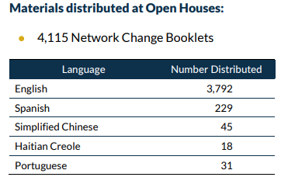

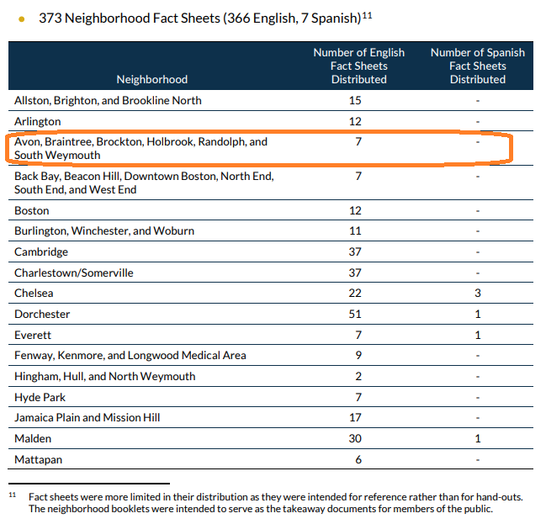

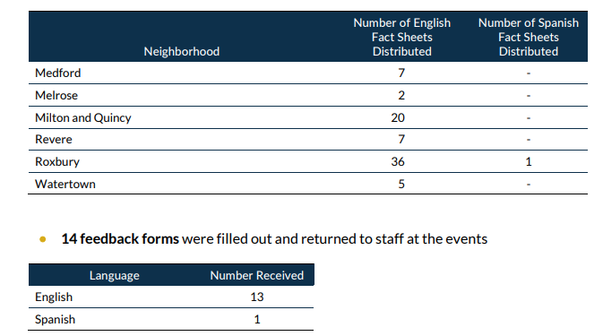

Model for Randolph: Acton shuttles people to commuter rail

South Acton Commuter Rail Station: Community Transportation Technical Assistance Program: MAPC willing and able to assist Randolph
https://www.mapc.org/wp-content/uploads/2017/11/SouthActon_2012-02-16.pdf

Introduction

The South Acton commuter rail station (shown in Figure 1) is located on the Massachusetts Bay Transportation Authority (MBTA) Fitchburg commuter rail line, approximately 25 miles northwest of North Station in Boston. The South Acton commuter rail station provides service to the three largest employment areas for Acton residents (excluding Acton itself) – Boston, Concord, and Cambridge.

According to the most recent MBTA System wide Passenger Survey, 61 percent of South Acton commuter rail station users reside in Acton and 94 percent of trips are for work purposes. A detailed list of survey results is included in Appendix 1.

The South Acton station has the most weekday daily boardings of all stops on the Fitchburg Line with approximately 850 boardings on one shared inbound/outbound platform.1 As part of an upgrade along the Fitchburg Line, the commuter rail will be upgraded to a double track from Boston to Ayer to increase train speeds and on-time performance. As part of this work, the South Acton commuter rail station will be expanded to a dual-platform.

Additional Public Transportation/Shuttles

No fixed route bus service is provided in Acton. In order to provide an alternative to personal vehicle use, the Town has a MinuteVan service that citizens can utilize. The MinuteVan operates between 6:45 - 9:25 a.m. for inbound commuters and 5:10 -7:30 p.m. for outbound commuters. Annual park and ride memberships are available for $250. The shuttle runs between the South Acton commuter rail lot and two off-site parking lots: the West Acton Fire Station, and the Mt. Calvary Church. The shuttle ride from the West Acton Fire Station is approximately 15 minutes, and the ride from Mt. Calvary Church lasts approximately 5 minutes. Annual passes for the shuttle service alone (i.e., without parking) are available for $200, and anyone may pay $10 for a book of ten ride tickets. The MinuteVan was observed dropping off commuters in the morning and picking up commuters in the evening (generally one van passenger per train).

In addition to the MinuteVan, the Clock Tower Place office park in Maynard provides shuttle service for employees to and from the South Acton commuter rail station. As there are limited trains running outbound from Boston in the morning and inbound in the afternoon, there are limited opportunities for Clock Tower Place employees to take the commuter rail. Approximately 7 employees were observed utilizing the shuttle service to the station in the evening.

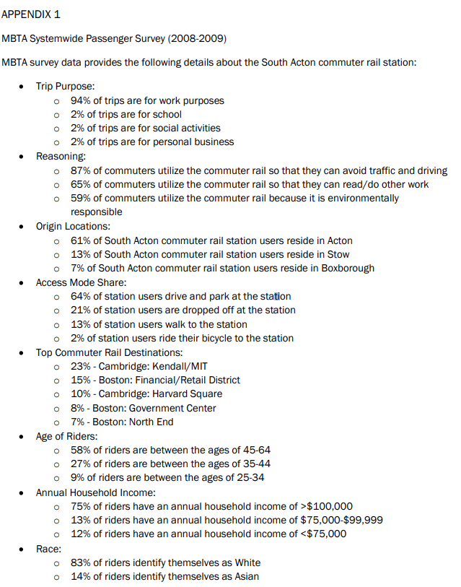

Town of Acton Transportation Services: MinuteVan dial-a-ride; Cross Acton Transit (CAT bus); “Acton Ride” taxi program
https://www.acton-ma.gov/626/Transportation-Services

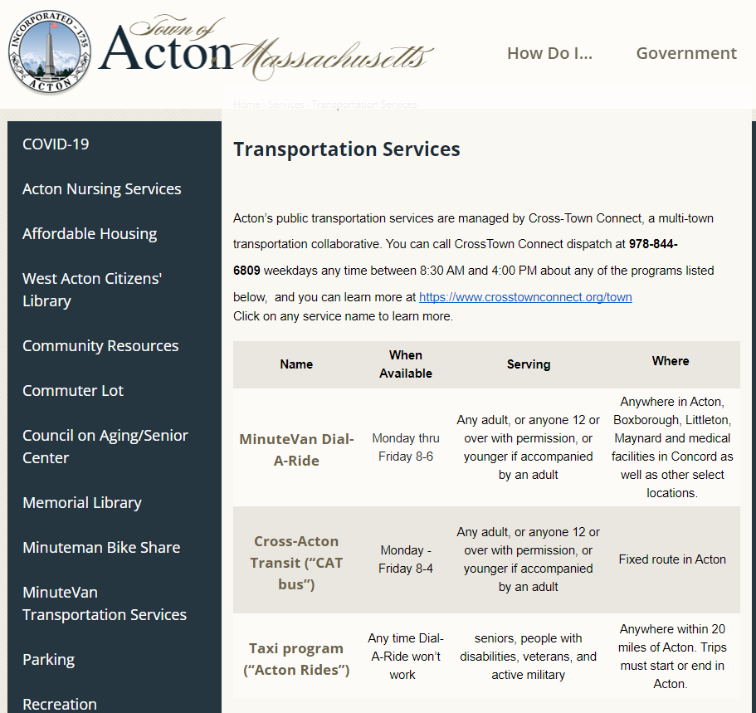

Ride the CAT: Cross Acton Transit schedule (hourly fixed route from 8 AM to 4 PM including MBTA commuter rail station)

https://irp.cdn-website.com/2488e3cf/files/uploaded/2022%2001%2024%20Ride%20the%20Cat.pdf

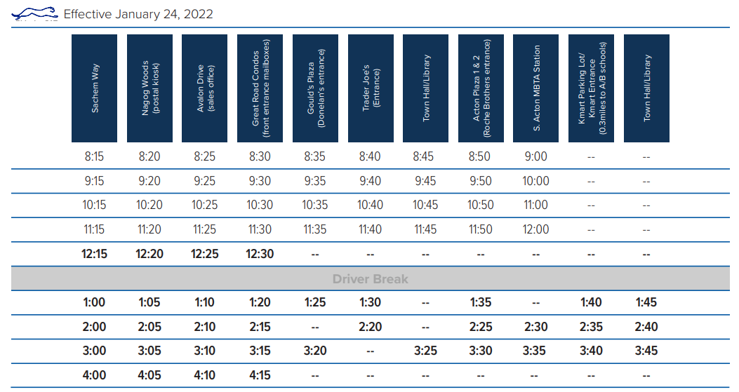

Maynard–Acton Rail Shuttle: expanded to Maynard, from Acton Commuter Rail station
https://www.crosstownconnect.org/commuter#MaynardActonRailShuttle

Hours of Operation

Monday thru Friday
6:10 AM - 8:35 AM
4:45 PM - 7:41 PM

Please note, the shuttle does not run on the following holidays: New Year’s Day, Martin Luther King Jr. Day, President’s Day, Patriot’s Day, Memorial Day, Independence Day, Labor Day, Columbus Day, Thanksgiving and the day after, and Christmas Day.

Where Can I Go?
Service Stops:
- Parker/Drummer
- PSHQ
- Maynard Golf
- Downtown Maynard
- Mill & Main
- MBTA Commuter Rail Station in South Acton
For a full list, please download the Maynard - Acton Rail Shuttle Schedule.

How Much Does It Cost?

$2 per trip (one way)

